**Problem 3** Propose a topic for a course project.

Use machine learning to classify the types of galaxies, e.g., spiral or elliptical, from some existing database.

**Problem 1.**

1. The default neural network  
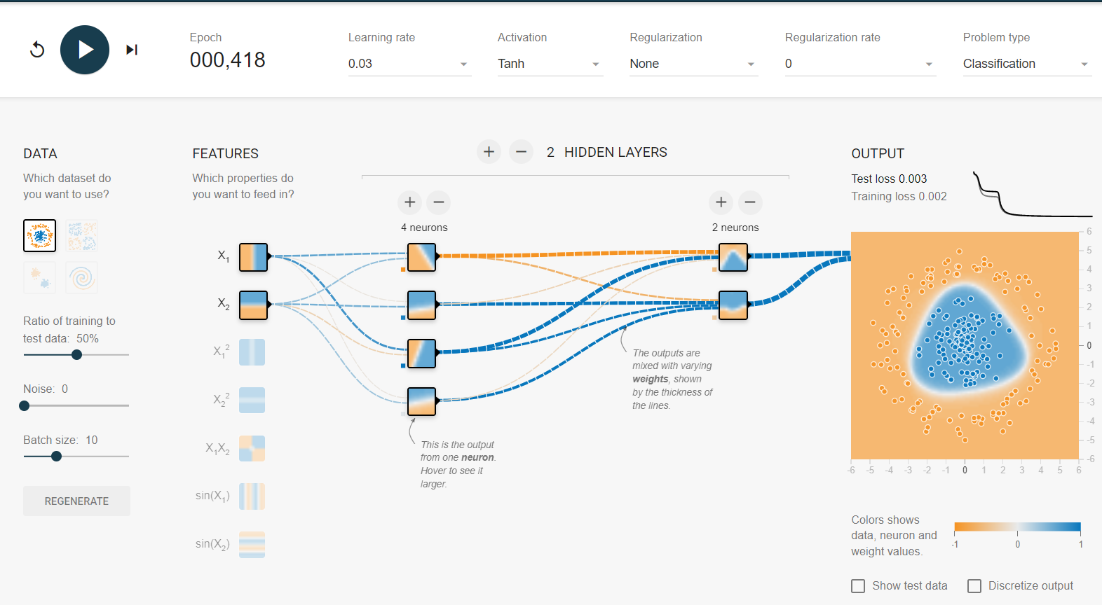

2. With ReLU activation  
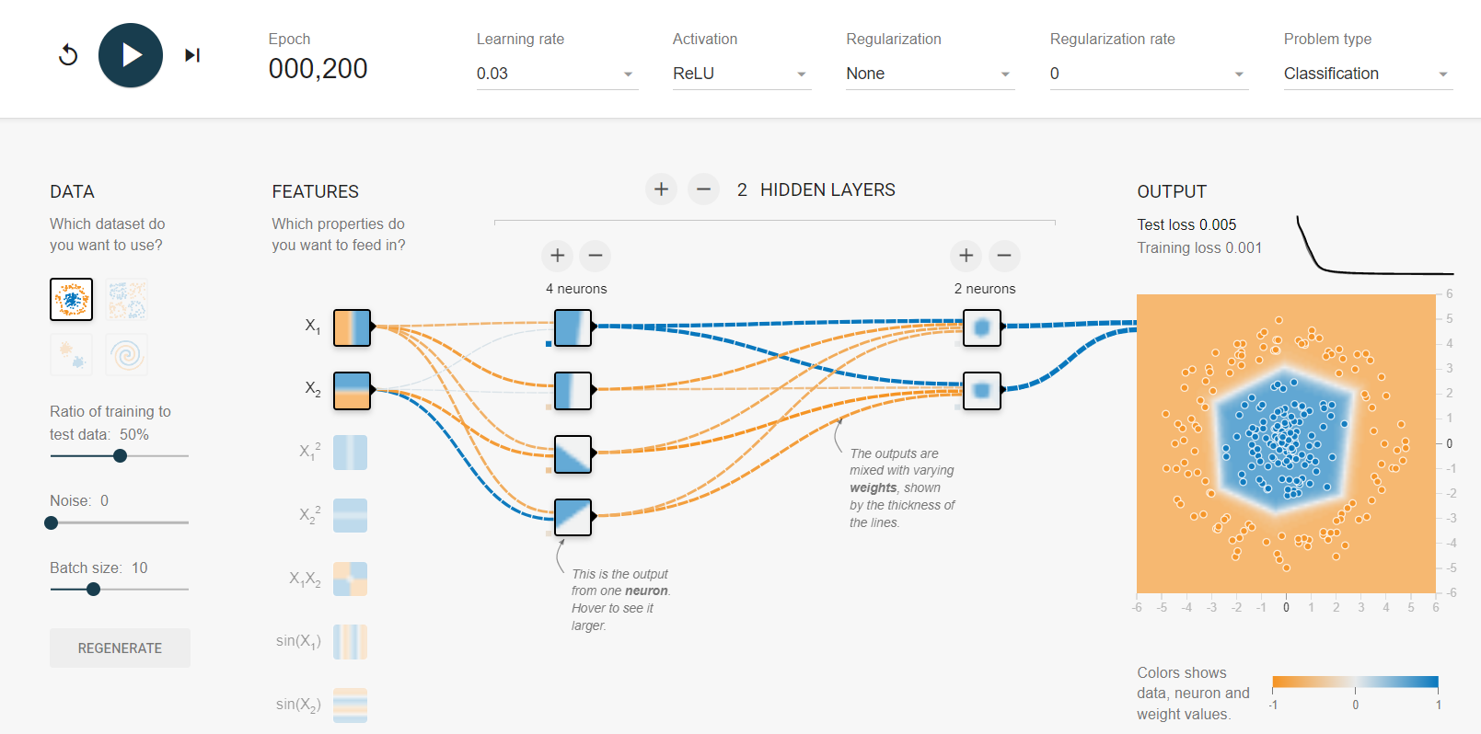

3. With only one hidden layer of 3 neurons  
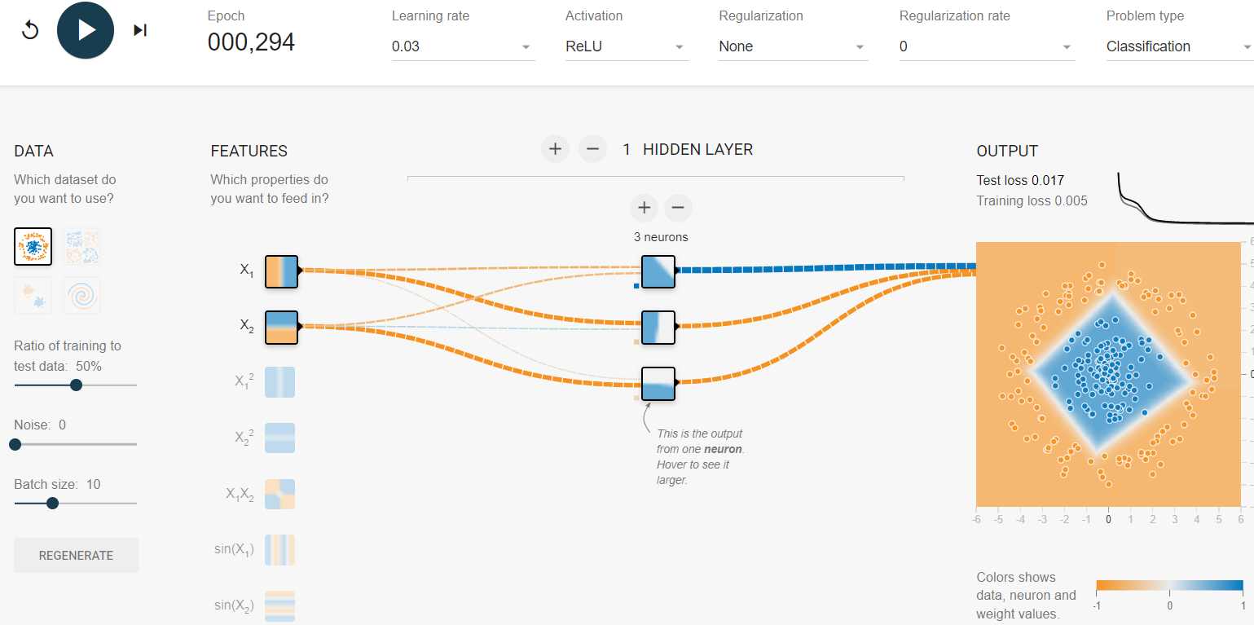

4. With only two neurons in the hidden layer  
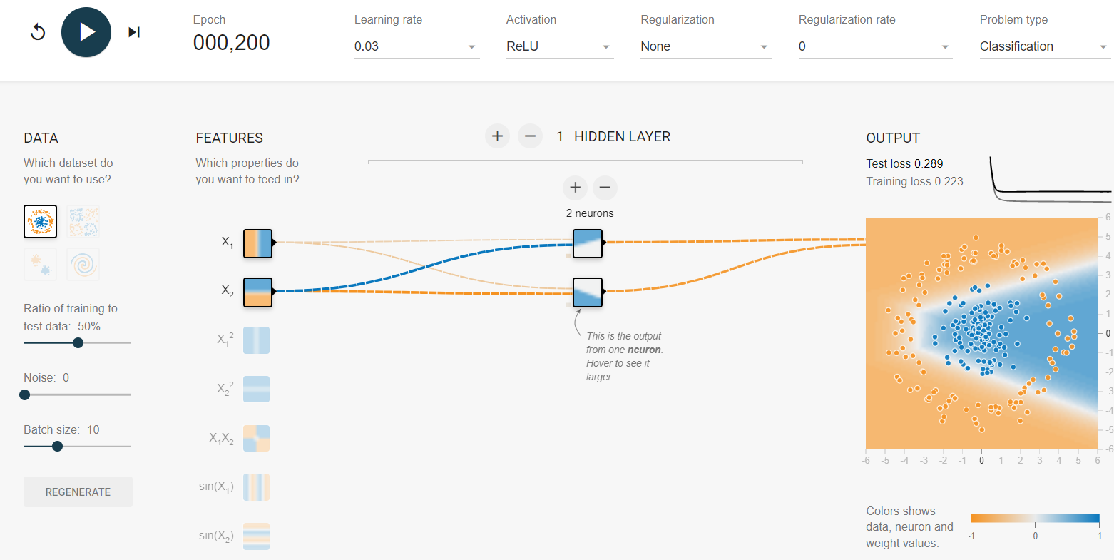

5. With 8 neurons in the hidden layer  
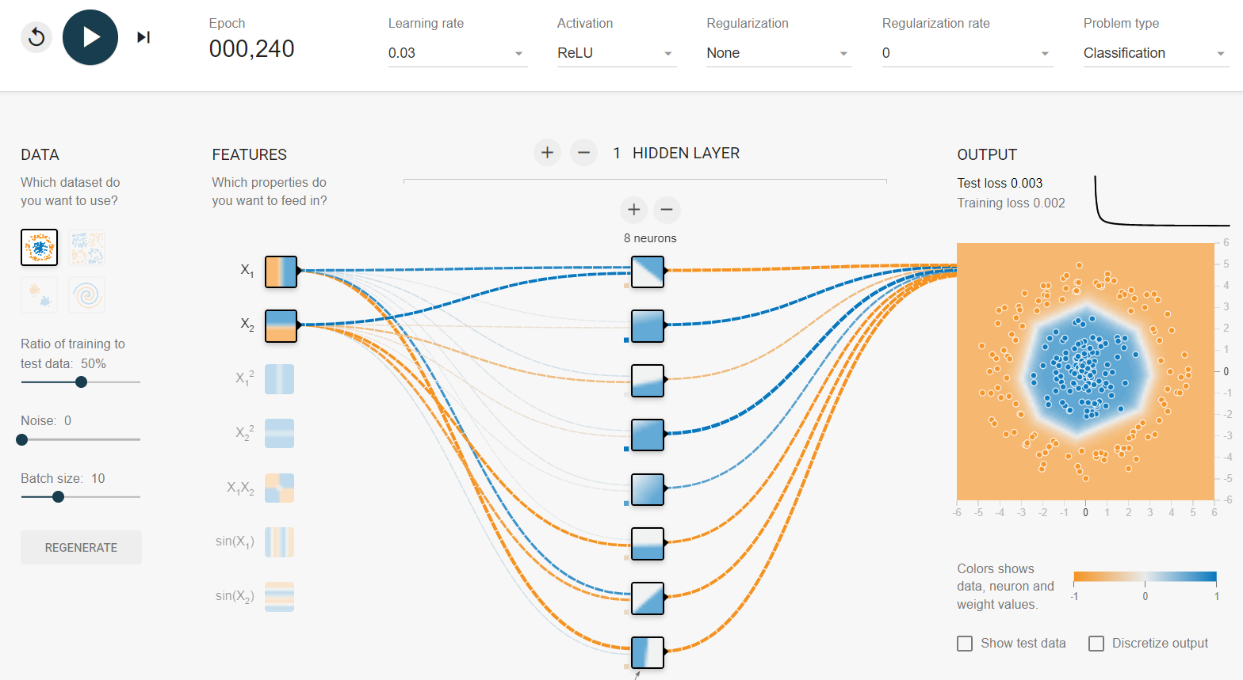

6. The training had a long plateaus before got a relatively good solution.   
